# AMS-GMNS Data Hub

As an open-source data hub processing and visualization tool, AMS-GMNS network supports the data linkage with the following tools/utilities:

(1) Network & Demand Data, created manually through NEXTA or prepared based on popular data file format (csv, Excel, XML). These data sets can be imported into NEXTA to serve as the base for mesoscopic DTA simulation and other modeling tools.

(3) Network database, link-based Measure of Effectiveness (MOE) and vehicle trajectory files from mesoscopic DTA simulation.

(4) Field Data: Traffic counts, speeds, travel time from multiple locations and multiple days.

(5) HCM Quick Estimation Method (QEM) and Synchro® Singal Optimization Prep& Import/Export. The network and trajectory data from (2) and (4) should be converted by data hub tool (e.g. NeXTA) first to generate movement-specific turning volume.

(6) Web-based and 3D map visualization (through KML files for Google Earth and CSV file for Google Maps and Goolge Fusion Tables)

(7) Microscopic traffic simulation packages. E.g. a subarea of traffic network and path flow counts can be exported to VISSIM for detailed operational analysis.

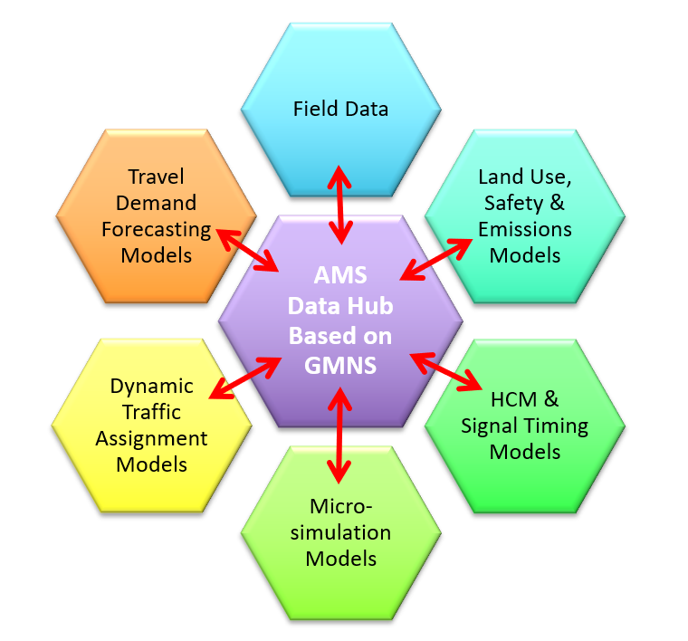

# OSM2GMNS

OSM2GMNS is a tool for generating GMNS standard data file from OpenStreet Map. OpenStreet Map (OSM) is a free, crowdsourced, worldwide mapping project and geospatial data repository. This user guide describes a data conversion tool of OMS2GMNS based on the OSM map data and then generate node and link network file in the GMNS (General Travel Network Format Specification) format.

A transportation network in GMNS format typically includes **node.csv** and **link.csv** files, as shown in the following table.

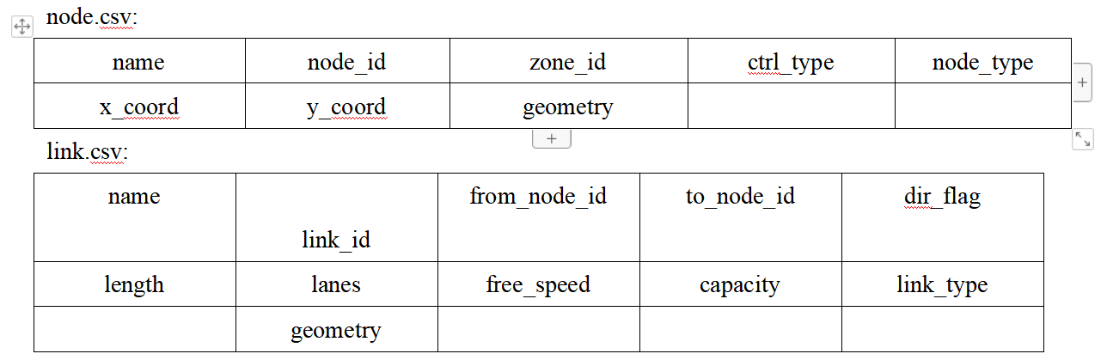

<https://github.com/asu-trans-ai-lab/OSM2GMNS>

# GTFS2GMNS

The General Transit Feed Specification (GTFS) defines a common format for public transportation schedules and associated geographic information. It is used by thousands of public transport providers. As a data conversion tool, gtfs2gmns, can directly convert the GTFS data to node, link, and agent files in the GMNS format.

<https://github.com/asu-trans-ai-lab/GTFS2GMNS>

# GRID2DEMAND

GRID2DEMAND is a quick trip generation and distribution tool based on the four-step travel model. First, the research region is divided into grid zones of the same scale. POI nodes are used to generate node production/attraction. Second, trip distribution is achieved by a typical gravity model.

**3.1. Data files**

Input files are the network files in GMNS format (*node.csv, link.csv, poi.csv*), which can be automatically generated by the OSM2GMNS tool. Node and POI files will be used for generating demand, and *poi.csv* may need manual edition.

Output files are *zone.csv, accessibility.csv, poi_trip_rate.csv,* and *demand.csv*. Final zone-to-zone demand is listed in *demand.csv* with geometry.

**3.2. Grid partition**

Grids are automatically generated by a given scale of degree or number of zones in the research region. Each grid is regarded as TAZ used for trip generation and distribution. The grid information is stored in *zone.csv*.

**3.3. Node demand**

All types of POI nodes are collected from *poi.csv*. The values of production and attraction under each trip purpose and POI type are defined by default or by users. Therefore, the production and attraction values of each node can be calculated. The POI node production/attraction rates used in the model are summarized in *poi_trip_rate.csv*. The node information is updated in *node.csv*.

**3.4. Accessibility**

Accessibility is measured by zone-to-zone distance according to zone centroid coordinates. A degree at different latitudes represents different lengths on a flat surface. According to a given latitude, the closest latitude in the following table is selected to calculate the longitudinal length.

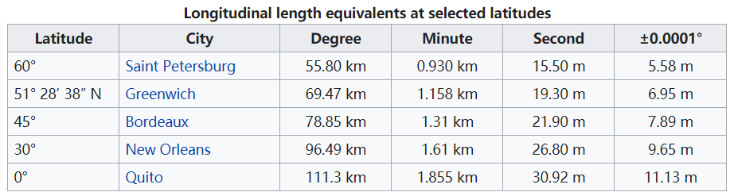

**3.5. Gravity model**

For each OD pair, a typical gravity model is applied to calculate zone-to-zone demand volume.

$$T_{ij}=P_{i}∙\frac{A_{j}∙F_{ij}∙K_{ij}}{\sum_{j}{\left(A_{j}∙F_{ij}∙K_{ij}\right)}}$$

$$F_{ij}=e^{βd_{ij}-g}$$

where  is total trips from zone 𝑖 to zone 𝑗;  are productions in zone 𝑖 and attractions in zone 𝑗, respectively;  is the friction factor for travel from zone 𝑖 to zone 𝑗 ;  is the correction factor for travel from zone 𝑖 to zone 𝑗, equal to 1 by default; parameter  is equal to -0.1 by default; parameter  is equal to 0 by default.

<https://github.com/asu-trans-ai-lab/grid2demand>

The framework of GRID2DEMAND is illustrated in the following figure.

